Get To This Document

<https://goo.gl/W1hfbf>

FORUMS FOR ASKING & ANSWERING QUESTIONS

1. <https://forum.golangbridge.org/>
2. [subscribe to Go](https://drive.google.com/file/d/0B22KXlqHz6ZNYmQzN01JOTVRWGs/view?usp=sharing) on http://stackoverflow.com/

GITHUB CODE - Go Language Fundamentals

<https://github.com/GoesToEleven/GolangTraining>

GITHUB CODE - Go Web Programming

<https://github.com/GoesToEleven/golang-web-dev>

COURSE OUTLINE

<https://goo.gl/K5GccY>

STAY CURRENT - FOLLOW ME

TWITTER

<https://twitter.com/Todd_McLeod>

GOOGLE+

<https://goo.gl/kWyztP>

YOUTUBE

[https://www.**youtube**.com/user/**toddmcleod**](https://www.youtube.com/user/toddmcleod)

GREAT BOOKS:

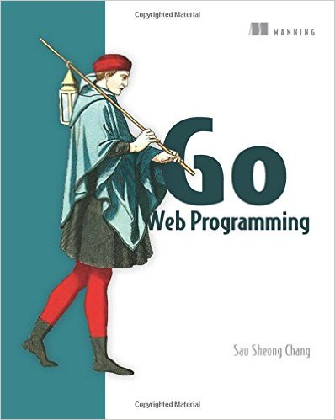  
I **love** this book. This book is GREAT. If you want to learn **web programming with Go**, this is the book you need.

[Buy on Amazon ( http://amzn.to/2dVlW07 )](http://amzn.to/2dVlW07)

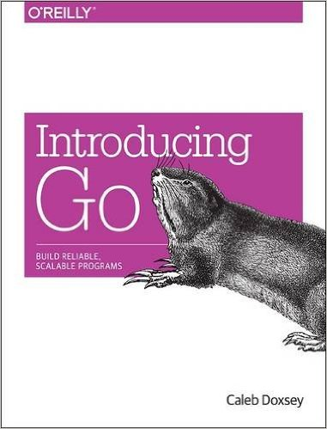

This book is also very approachable and great for beginners.

[Buy On Amazon ( http://amzn.to/1OnFtPY )](http://amzn.to/1OnFtPY)

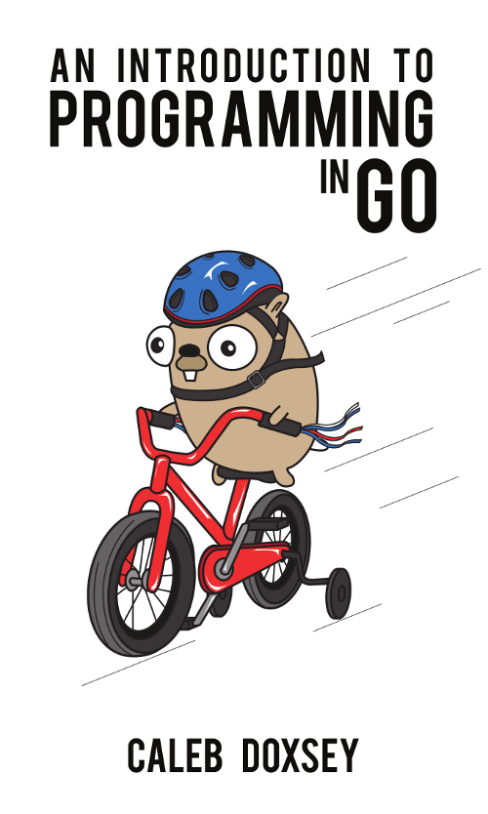  
Great online resource offered by Caleb Doxsey for free

[Read it online for free ( www.golang-book.com )](http://www.golang-book.com/books/intro)

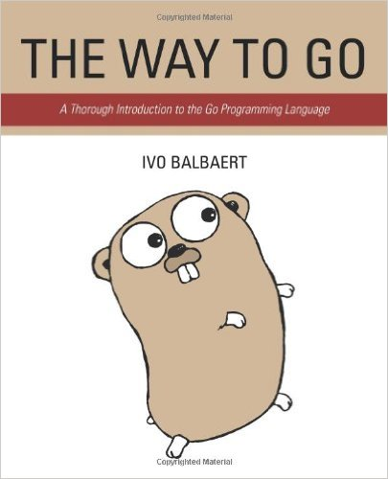  
While this book is the oldest of all of these, it is also very good for beginners. Jump over the first few chapters and start on Chapter 4.

[Buy On Amazon ( http://amzn.to/1PmlKSB )](http://amzn.to/1PmlKSB)

[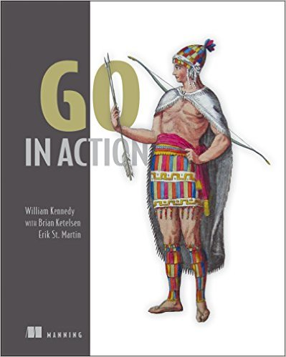](http://amzn.to/1kGGsPv)

Another great book. I’d categorize this one as intermediate. If you have some programming experience, this is a great book with which to begin. Chapter 2 is a bit advanced, as is chapter 7. Consider reading those two chapters last!

[Buy On Amazon ( http://amzn.to/1PmlB1w )](http://amzn.to/1PmlB1w)

[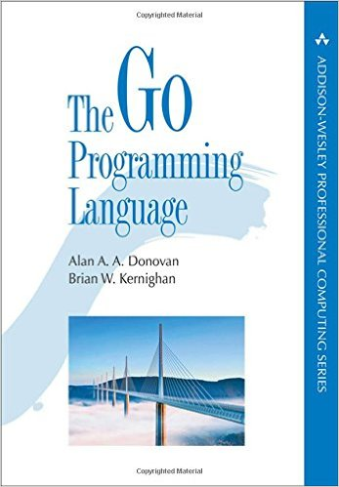](http://amzn.to/1RIM5HP)  
A fantastic book, very thorough, but more advanced. Purchase this with one of the other two books above so that you can get different perspectives on the same concept.

[Buy on Amazon ( http://amzn.to/21nO1Mc )](http://amzn.to/21nO1Mc)

FREE TRAININGS:

Go and Web Programming

* My lectures
  + youtube playlist
    - <https://www.youtube.com/playlist?list=PLSak_q1UXfPpXj-q1BeucvBAlNdotQWVD>
  + code base
    - <https://github.com/GoesToEleven/golang-web-dev>
* Caleb Doxsey's lectures
  + youtube playlist
    - <https://goo.gl/BjXZol>
  + index of videos
    - <https://goo.gl/k0pmRO>
  + code base
    - <https://github.com/golang-book/bootcamp-examples>

ARDAN TRAINING:

Bill Kennedy’s Ardan Lab “Ultimate Go” Training:

* <https://www.ardanlabs.com/ultimate-go>